**NUST SCHOOL OF ELECTRICAL ENGINEERING AND COMPUTER SCIENCE**

**(SEECS)**



**PROJECT REPORT**

|  |  |
| --- | --- |
| **MEMBER NAME** | **CMS ID** |
| Marriam Naeem |  |
| Misbah Juwayriyyah |  |
| Muhammad Saadan |  |

**Submitted to: Dr. Ahsan Saadat**

**Table Of Contents:**

1. About Project 4

2. Project Analysis 5

2.1. Purpose: 5

2.2. Existing System: 5

2.2.1. Limitations of Existing System: 5

2.3. Proposed System: 6

2.4. Solution to Complex Engineering Problem: 6

3. Requirement Analysis 6

3.1. Scope: 6

3.2. Users of the System: 7

4. Software Requirements 7

5. System Design 7

5.1. E-R Diagram: 7

6. System Specific Module 8

6.1. Administrator Module: 8

6.2. Tourist Module: 9

6.3. Student Module: 9

7. Flow of Events 10

7.1. UI Design: 10

7.2. Windows: 10

7.2.1. Main Window: 10

7.2.2. Admin Window: 10

• Admin Window: 11

• View Tables: 12

• Update Table: 12

• Change Number: 13

• Delete Account: 14

7.2.3. Student Window: 14

• Menu Options: 15

• Diplay Window: 16

7.2.4. Tourist Window: 16

• Menu Option: 17

• Diplay Window: 17

7.2.5. Create New Account: 18

7.2.6. Change Password: 18

7.3. Show City Map: 19

8. Database 21

8.1. Explanation: 21

8.2. Database Tables 21

a. Hospitals: 22

b. Shopping Malls: 22

c. Public Transport: 22

d. Police Stations: 23

e. Schools: 23

f. Hotels: 24

g. Libraries: 24

h. Universities: 24

i. ATMS: 25

j. Cinemas: 25

k. Hostels: 25

l. Restaurants: 26

9. Database Connectivity 26

9.1. Connect Class: 26

9.2. Retrieve Data 27

9.3. Login/Logout: 27

10. Java Concepts 27

10.1. Setters And Getters: 28

10.2. Constructor: 28

10.2.1. Default Constructor: 28

10.2.2. Parameterized Constructor: 29

10.2.3. Constructor Overloading: 29

10.3. Static Class Members, this Reference: 29

10.4. Inheritance and Abstraction: 30

10.5. Superlass and Subclass: 30

10.5.1. Super Class: 30

10.5.2. Sub Class: 31

10.6. UML Diagram: 31

10.7. Exception Handeling: 33

10.8. Graphical User Interface: 33

10.8.1. JFrame: 33

10.8.2. ContentPane: 34

10.8.3. JLabel: 34

10.8.4. JtextArea: 35

10.8.5. JtextField: 35

10.8.6. JpasswordField: 36

10.8.7. JButton: 36

11. Conclusion: 38

**Table Of Figures:**

Figure 1. main window 12

Figure 2. Admin Window 1 12

Figure 3. Admin window 2 13

Figure 4. admin display 13

Figure 5. Admin Update 14

Figure 6. Change Number 15

Figure 7. Delete Account 15

Figure 8. Student Window 1 16

Figure 9. Student Window 2 16

Figure 10. Student Display 17

Figure 11. Tourist Window 1 17

Figure 12. Tourist Options 18

Figure 13. Tourist Display 18

Figure 14. ceate Account 19

Figure 15. change password 19

Figure 16. Map 20

Figure 17. Map code 1 21

Figure 18. Map code 2 21

Figure 19. map Code imports 21

Figure 20. database table code 22

Figure 21. hospitals 23

Figure 22. Shopping Malls 23

Figure 23. Public Transport 23

Figure 24. Police Stations 24

Figure 25. Schools 24

Figure 26. Hotels 25

Figure 27. Libraries 25

Figure 28. Universities 25

Figure 29. ATMS 26

Figure 30.Cinemas 26

Figure 31. Hostels 26

Figure 32. Restaurants 27

Figure 33. connect class 27

Figure 34. retrieve data 28

Figure 35. login/logout 28

Figure 36. Setters and getters 29

Figure 37. default Constructor 29

Figure 38. Parameterized Constructor 30

Figure 39. this reference 30

Figure 40. inheritance 31

Figure 41. exception handeling 1 34

Figure 42. exception handeling 2 34

Figure 43. JFrame code 1 34

Figure 44. Jframe code 2 35

Figure 45. contentPane code 35

Figure 46. Jlabel code 35

Figure 47. JTextArea code 36

Figure 48. JTextArea Output 36

Figure 49. JTextField code 36

Figure 50. JTextField value 36

Figure 51. JPasswordField code 37

Figure 52JPasswordField output 37

Figure 53. JPasswordField value 37

Figure 54. Action evevt 38

Figure 55. actionlistener interface 38

Figure 56. action event 2 38

# Introduction:

# About Project

City Guide is essential whenever we are visiting a particular city. It gives us valuable information about the city and saves our time. Our project laid a GUI-based platform for the city guide and can search every place in the city without taking the help of any personal guide. The city we have taken for this project is the capital and the most important city of Pakistan i.e Islamabad. You can search for prominent places in *Islamabad* and can get social and recreational information about the city. It provides you a guide about everything from the scratch and helps you settle in here, without taking any help from anyone else. The services regarding the city’s historical places, conventional places, bus routes, hotels, restaurants, hospitals, educational institutes, etc. are provided by this project.

Our project title is ‘SMART CITY’, a GUI-based product used to store the details of Islamabad and helps all the users who use our project. The application contains complete information about Islamabad, like places to be visited, site maps, route maps, etc. This application can be used by any person who comes to Islamabad whether as a Student, or as a Tourist and is facing difficulty regarding which hotel to book, which place is good to visit and which is not, or for students to search for any educational institute and see which is good enough and where he/she can take admission.

# Project Analysis

## Purpose:

The main aim of this project is to provide the users who have registered, the information about the city’s history, and the location of all the important places and help them know more about Islamabad. This contains different modules for two different categories of people who might visit Islamabad and need any help with the city guide. These two categories might be:

* Students
* Tourists

Students might come to Islamabad for educational purposes , as Islamabad has Pakitan’s famous educational institutes. This project would help them settle here and search for everything they might need on one platform and get authentic infromation, instead of gathering information from different platforms and people and then checking whether that is authentic or not. Same is for the toursits, they may see any recreational or historical place , or any restaurant he/she wants to visit and can also see that place’s ratings. He can also veiw the whole city’s map using this application. Everything will be rpovided under one platform.

## Existing System:

In the existing system, the people who are visiting Islamabad, need to gather information from the person who is staying in the city or take the help of a guide in the city. Or they have to make a list of all their questions and need to google each and everything, that is a very time-taking process.

### Limitations of Existing System:

* The existing system is a manual system. The user has to first make a list of his queries, search up or ask anyone about the answers and information, check whether that information is authentic or not, then save that information in written form or soft form and then visit that city.
* It’s a limited system and less user-friendly. Only a few people use this, others just go to that city and then face difficulties.
* The manual system gives us very less security for saving data; some data may be lost due to mismanagement.

## Proposed System:

The Proposed System provides authentic information about the city under one platform. The development of this system contains the following activities, which try to automate the entire process while keeping in view the database integration approach.

* User Friendliness is provided in the application with various controls provides by the system Rich User Interface.
* It can be accessed by any person. All he has to do is make an account and access all the services provide.
* The city’s information is stored in the database system which can be maintained by the system.
* It is completely free of cost.
* Everything needed is provided under one platform.

## Solution to Complex Engineering Problem:

Keeping in view all the limitations of the existing system, the solution provided by the proposed system can be viewed as a solution to a complex engineering problem. In the existing system, it was a time taking process that required a little effort. Going to a new city is in itself a great task, especially for the students. Along with it, gathering information about the city and checking the authenticity of the information is a frustrating process and some people find it a lot of effort and don’t bother to do it at all. While the proposed system has made it a lot easier. All information about Islamabad is just a click away. All the information provides is authentic and credible. This is so easy to use that even lazy people can use it. The task was a tiring process previously has now become so easy. All you have to do to register your account and access all the information easily. It has provided a solution to a problem that was very complex and tiring for the people.

# Requirement Analysis

## Scope:

* It can be accessed by an unlimited number of users.
* Each user will be assigned a different set of permissions for each module of the system.
* Every user must have their USER ID & PASSWORD for security purposes
* Administrator is created in the system already.
* A person can make accounts in different modules depending upon their use.

## Users of the System:

Following people can use this system and avail the services:

* Students
* Tourists

# Software Requirements

* Windows XP
* Eclipse
* MYSQL Database- Oracle
* popsql
* JDBC
* Netbeans

# System Design

## E-R Diagram:

Name

Name

Username

Tourist

Username

Student

Password

Password

Manages

Administrator

Admin id

Password

# System Specific Module

There are three modules in our project. They are listed below:

1. Administrator Module
2. Tourist Module
3. Student Module

## Administrator Module:

The admin module is the major module as it is responsible for carrying out the major operations regarding any updates on the application. It maintains the information regarding the other two modules. The various software components in the administrator module include updating hospitals, updating restaurants, updating educational institutes, etc. The details regarding everything that is provided by the application are entered by the admin. The details regarding conventional places such as description, location, address, and contact number of the place he can also edit the details once entered.

## Tourist Module:

The tourist module is maintain the information regarding the city’s recreational places, hotels, restaurants, etc. The user after registration as a tourist is considered an authorized user. He/she can avail following services about Islamabad:

* View Hospitals
* View Restaurants
* View Hotels
* View Recreational Places
* View ATMs locations
* View Public Transports
* View Airports
* View Cinema Halls
* View Shopping Malls
* View Police stations
* View City Map

The tourist, once registered, can access any of these services just by the click of a button. He can also view the whole Islamabad’s map only by clicking one button.

## Student Module:

The student module maintains the information regarding various institutes in Islamabad. It basically helps a student settle in Islamabad for educational purposes. For example, when a student moves to a new city, he needs information regarding the educational institutes, hostels, and any other food places in that city. This application provides all these three things. Along with these, it also provides other services that are provided in the tourist mode i.e. hospitals, restaurants, hotels, police stations, etc. The following services are provided to the students:

* View Universities
* View Schools/ Colleges
* View Hostels
* View Libraries
* View Restaurants
* View Hospitals
* View Police Stations
* View ATM
* View City Map

# Flow of Events

# UI Design:

The UI of the project is designed using **java swing.** Java Swing is a part of Java Foundation Classes (JFC) that is *used to create window-based applications*. It is built on top of AWT (Abstract Windowing Toolkit) API and is entirely written in java. We could have used Javafx or AWT but Java swing is more **platform-independent** and has **more powerful components.** So that is whyall of the windows of our project are designed using Java Swing.

# Windows:

The UI windows design of the program is explained as:

## Main Window:

The main window designed has 3 buttons providing access to all of the three modules of the program i.e admin module, student module, and tourist module. Users can select any of the module’s buttons, and he/she will be directed to the windows of that specific module.

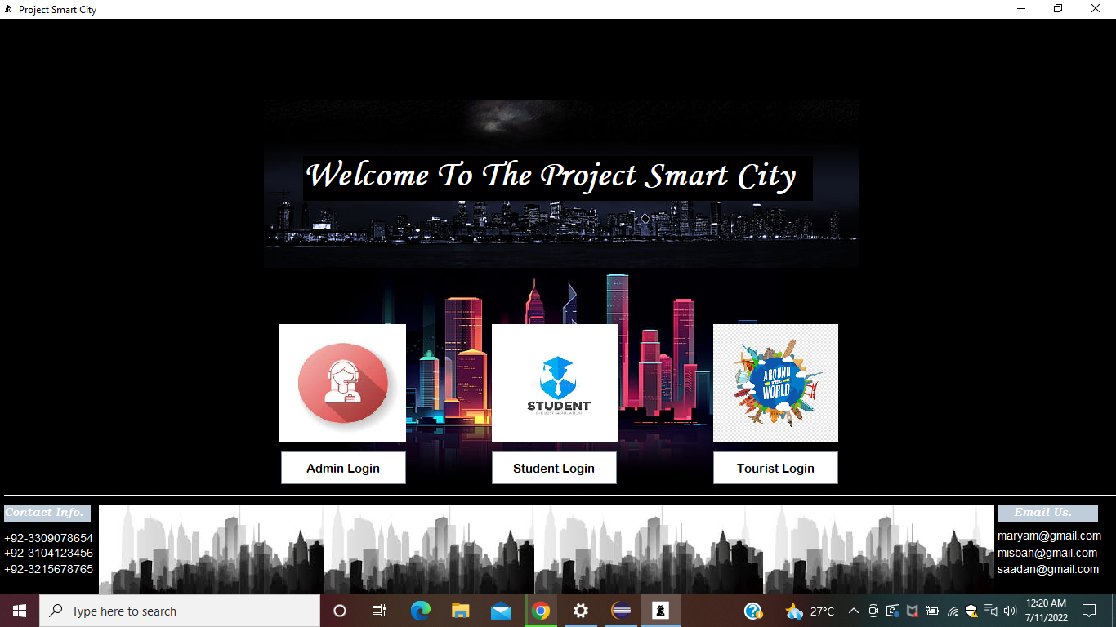

Figure . main window

## Admin Window:

If the user selects the button of the admin module, he will be directed to a login window. The account of the admin is already created in the database and only admins know its login details. So here, only the admin can log into the administrative account and make any updates to the information. For security purposes, there is no create new account option, only certified people can have access to the data. No usual person can log into the administrative data without knowing the system account login details, and that is confidential information, that only the administrators know. In this way, the data of the application is made unaccessible and safe from hackers.

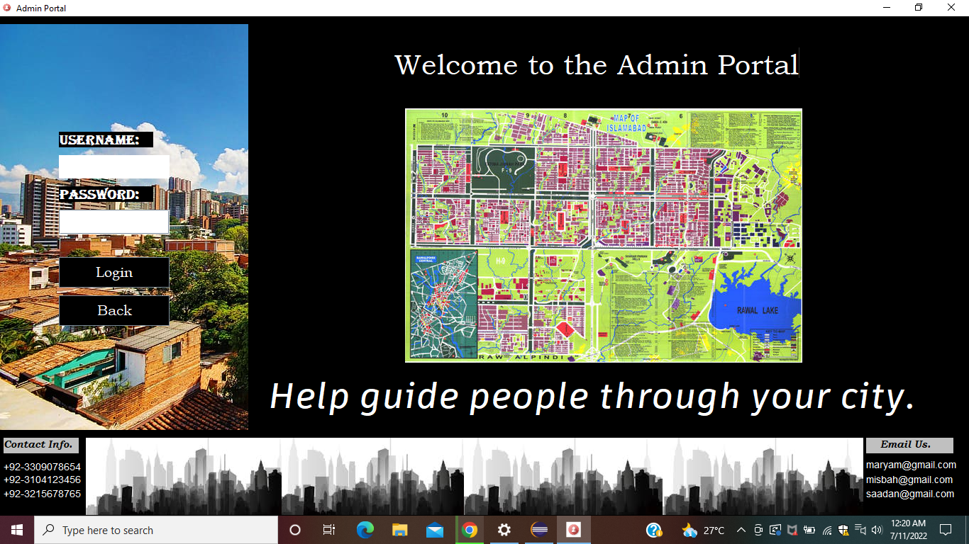

Figure . Admin Window 1

### Admin Window:

If the admin enters the correct login details, an update window is opened. On this window, there are several buttons and labels as shown:

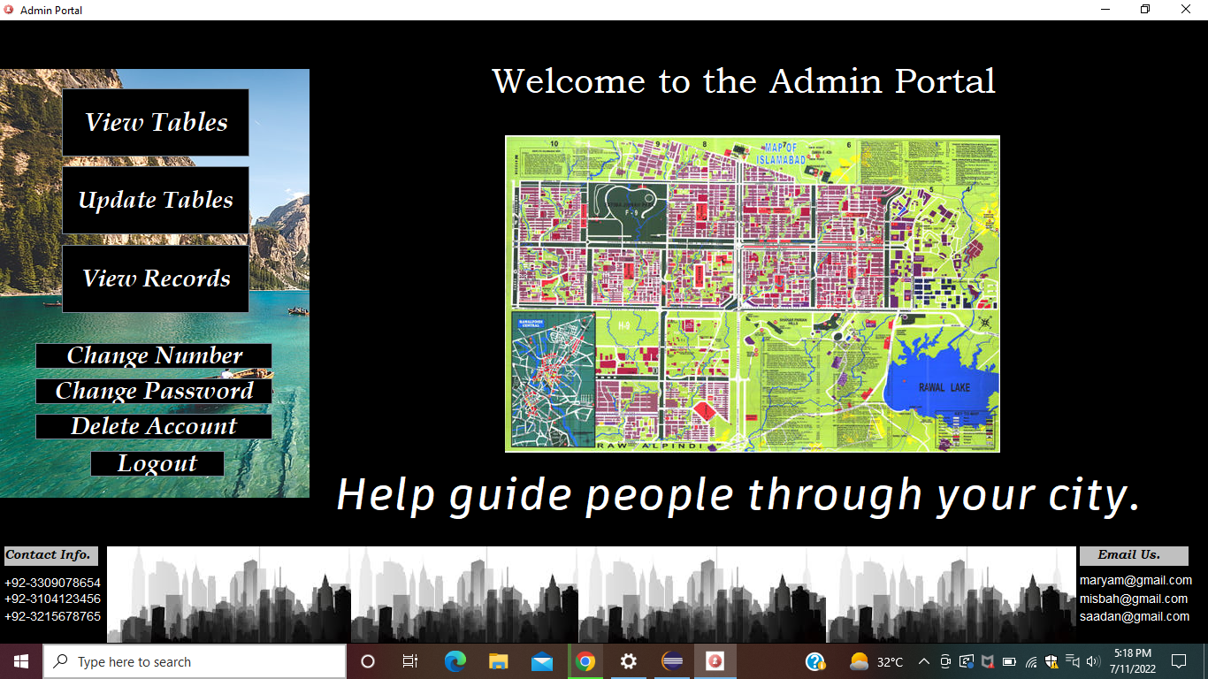

Figure . Admin window 2

### View Tables:

If the user enters the button “view tables”, then a window will be displayed with all the button options. If the user clicks the “show restaurants” button, then on the right side, the database table of hospitals will be displayed as:

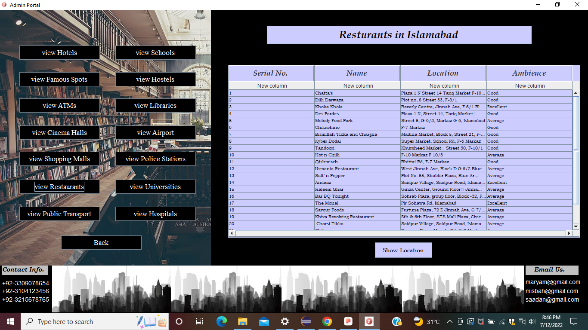

Figure . admin display

### Update Table:

If the admin enters the button “Update Table”, the following window will be displayed. On this window, there are different buttons (as shown in the figure). On clicking these buttons, different labels and text fields appear. For example, if the admin wants to make any change in the hospitals’ table of the database, he/she will click the “hospitals” button, and in the Jtextfields, he/she will enter the information about the hospital, belows these textfields, there are two buttons as “add”, “delete”. If the wants to add that specific hospital to the table, he will click the add button. Behind this button, there is a specific code that performs this action (explained later). And if he wants to delete that hospital from the table, he can enter the delete button and that entire row will be deleted from the database table. The same process is for all the other buttons on this window.

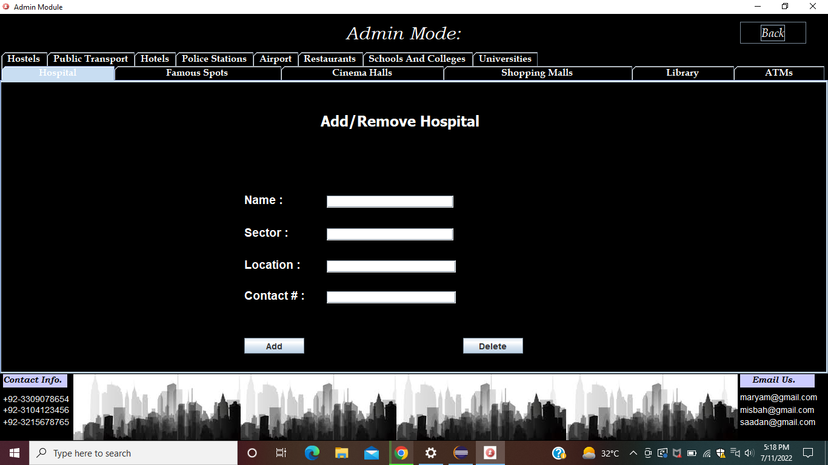

Figure . Admin Update

### Change Number:

If on the admin window, the admin clicks the button “Change Number”, the following window will be displayed. Here the user has to enter his credentials and click on the confirm button to update his/her phone number.

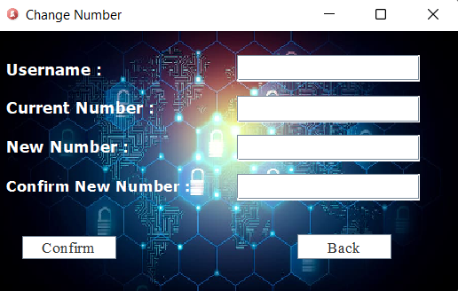

Figure . Change Number

### Delete Account:

If on the admin window, the admin enters the button “Delete Account”, the the following window will be displayed. Here the user has to enter his credentials and click on the delete button to delete his/her account from the database.

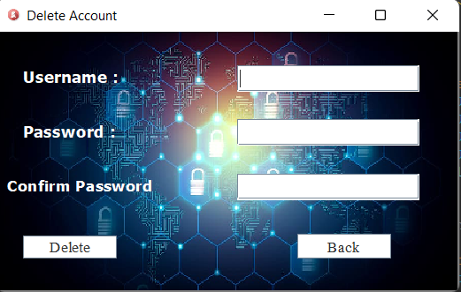

Figure . Delete Account

## Student Window:

If, on the main window, the user enters the button “Student Login”, he is directed to the student portal window. Here if The user already has an account, he can log into that account, and if he doesnot have an account, he can also create a new account by clicking the create new account button.

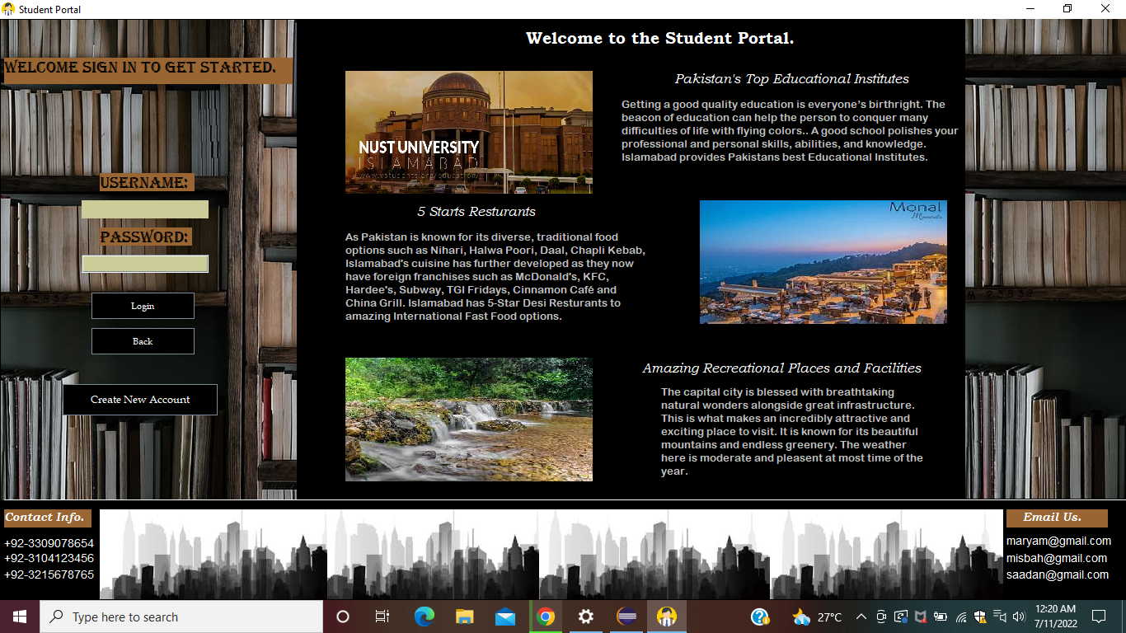

Figure . Student Window 1

### Menu Options:

After logging into the account, the user is displayed with all the options that he/she can avail. He can click on each button, and then a new window is displayed that contains all the information related to the query of the user. Here the information is displayed by loading the table from the database and displaying it (explained later).

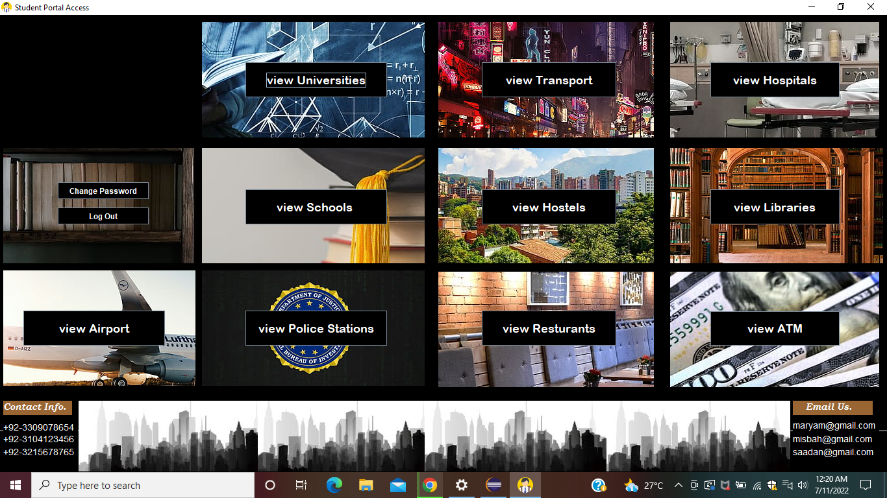

Figure . Student Window 2

### Diplay Window:

If on the previous window, the user enters “View Schools”, then the following window will be displayed. The table from the database is displayed.

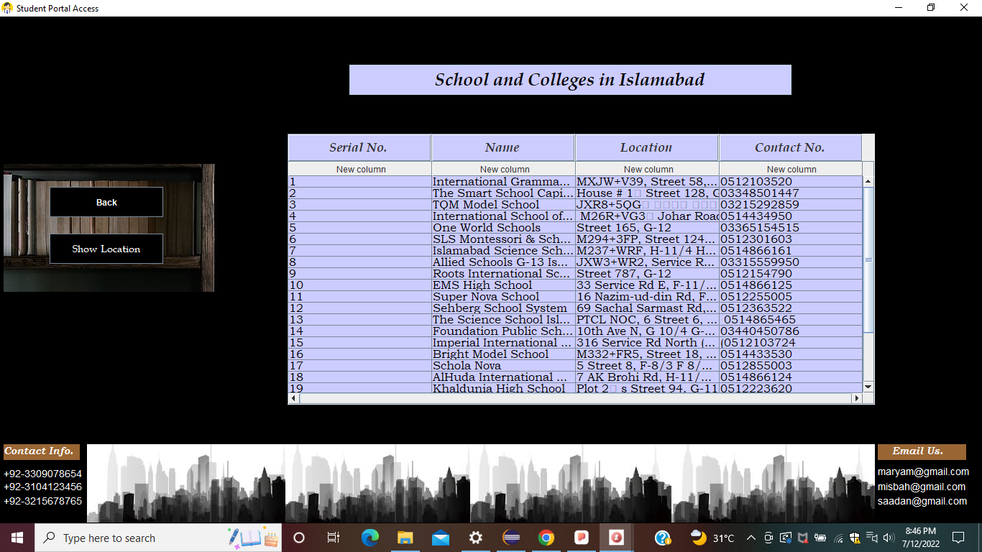

Figure . Student Display

Here, if the user clicks any row and clicks the button “show location” then the map of that particular institute will be shown.

## Tourist Window:

If, on the main window, the user enters the button “Tourist Login”, he/she is directed to the tourist portal windows. Here if The user already has an account, he can log into that account, and if he doesnot have an account, he can also create a new account by clicking the create new account button.

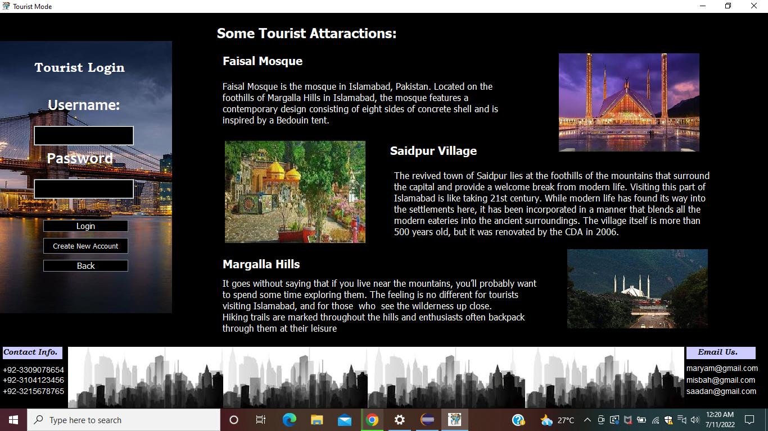

Figure . Tourist Window 1

### Menu Option:

After logging into the account, the user is displayed with all the options that he/she can avail. He can click on each button, and then a new window is displayed that contains all the information related to the query of the user. Here the information is displayed by loading the table from the database and displaying it (explained later).

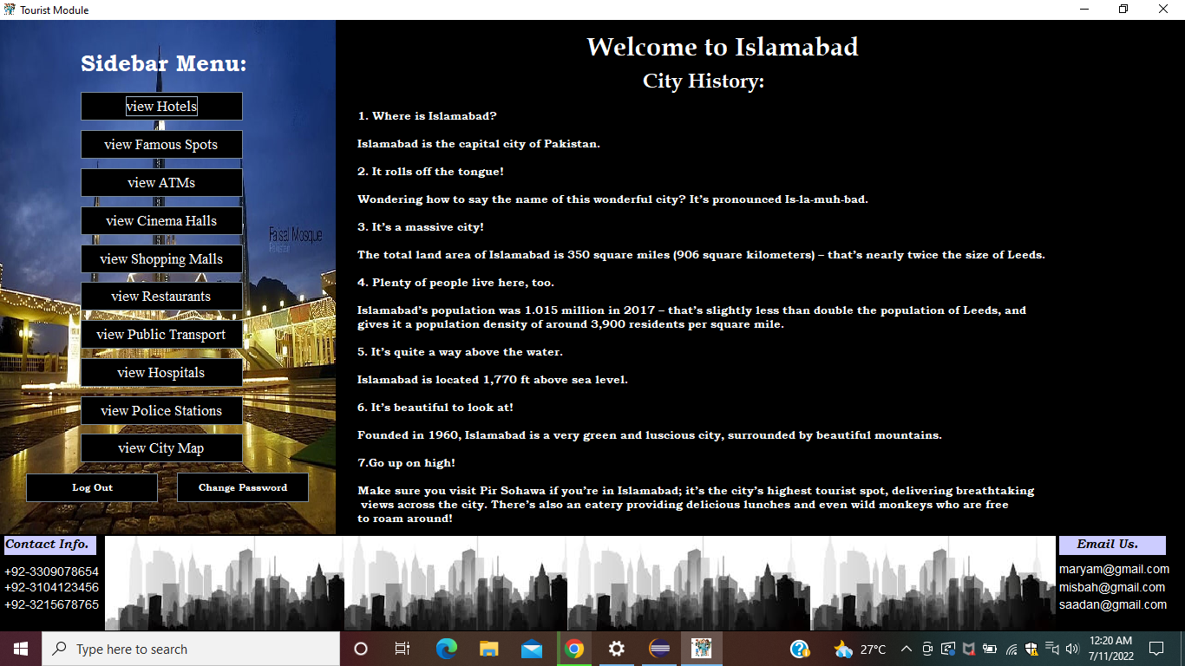

Figure . Tourist Options

### Diplay Window:

If on the previous window, the user enters “View Hospitals”, then the following window will be displayed. The table from the database is displayed.

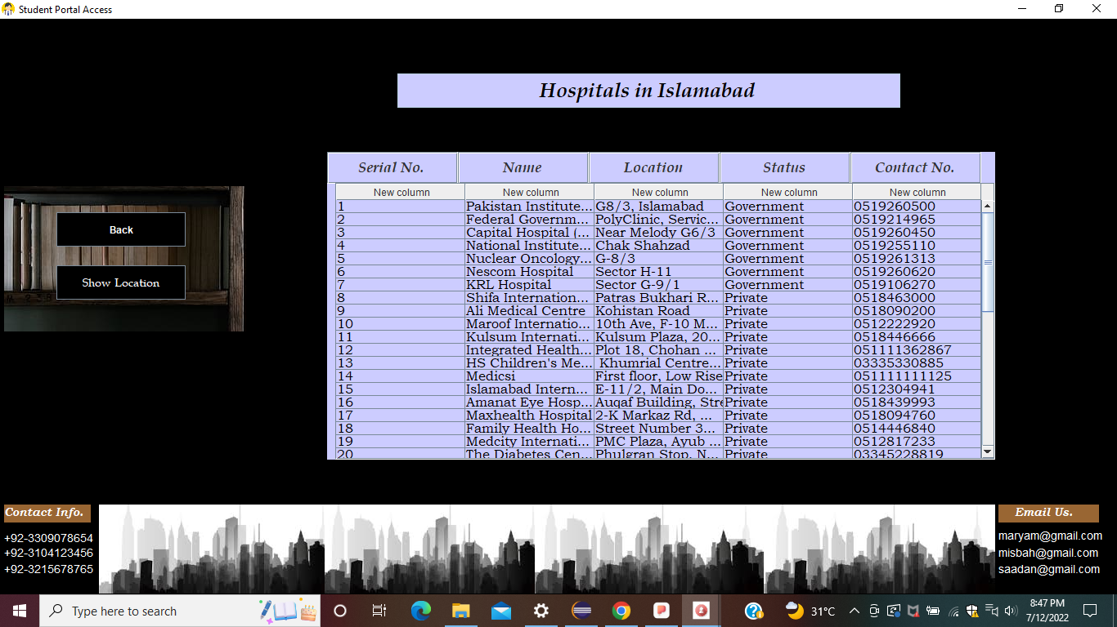

Figure . Tourist Display

Here, if the user clicks any row and clicks the button “show location” then the map of that particular institute will be shown.

## Create New Account:

If the user does not have any account previously, he/she can create a new account by clicking on the “Create New Account” button on each student or tourist portal. He will be displayed following widnow. The buttons on this widow are connected with the database at the backend.

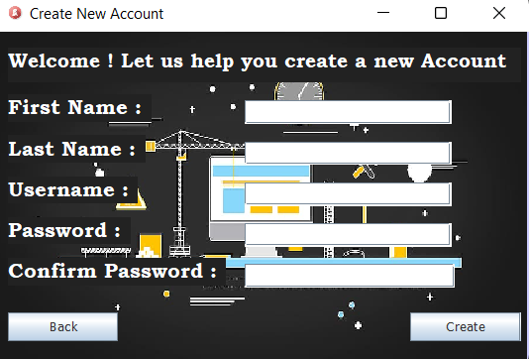

Figure . ceate Account

He/she can fill this form and click on the “create” button to create a new account. In this way, a new account row is added in the database tables, and the person can now access all the services provided.

## Change Password:

If a person wants to change his/her password, he can click on the “change password” button, a new window will be displayed where he/she can enter his/her previous password and new password and click on the “confirm” button to change his/her password.

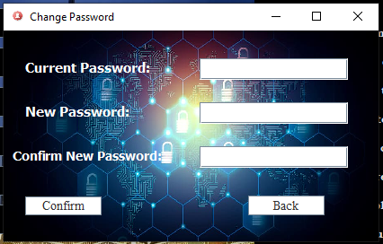

Figure . change password

# Show City Map:

Another feature of this program is that the user can view Islamabad’s whole map, without using the google maps. The map is displayed using the jxmapviewer. The diplay of the map is as:

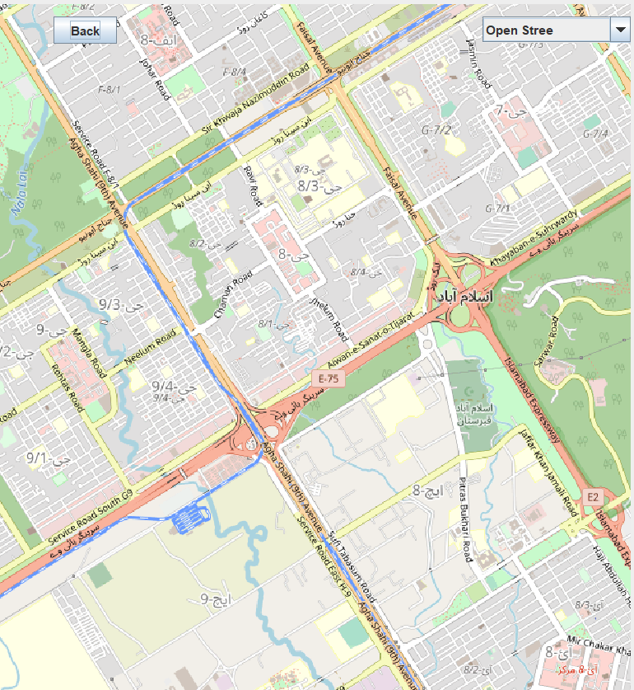

Figure . Map

When the user enters the button, “Show City Map”. This map is displayed to him . This provides the user each and everything related to Islamabad. And he needs not to use the google maps for directions. He has his own map on his app “Smart City”.

This is diplayed using the jXMapViewer jar file. Following block of code was written to display the map on the jFrame:

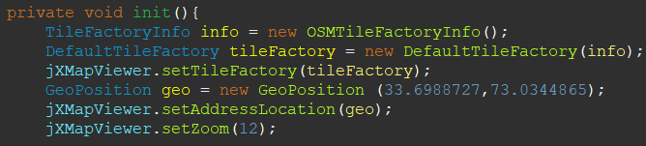

Figure . Map code 1

The TileFactoryInfo and DefaultTilefactory are classes in the jxmapviewer that are imported. Geoposition is set to the latittides nad longitutes of Islamabad. The above code just generates a map on the JFrame that is not interactive. To make the program interactive. We write the following block of code, we as the mouseListener to scroll through the map using the mouse.

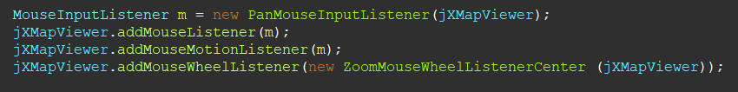

Figure . Map code 2

To write the above block of code, we made following imports:

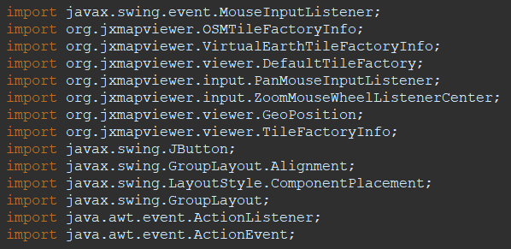

Figure . map Code imports

# Database

## Explanation:

The applications MySQL and POPSQL are used to create the database for the given project. The data is in the form of Tables so it is easy to add, delete and update. The format of the Tables is given down below.

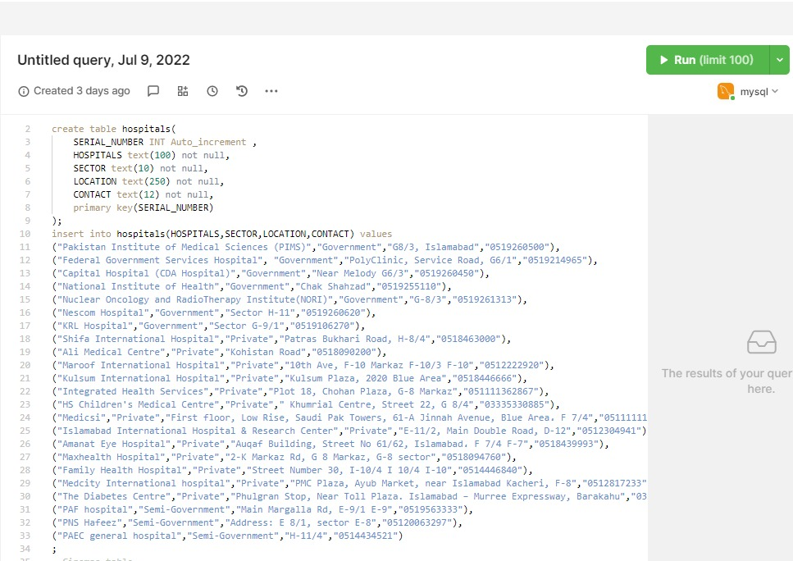

Figure . database table code

All the other tables are made following the same pattern.

## Database Tables

All of the tables that are made in the database are shown below:

### Hospitals:

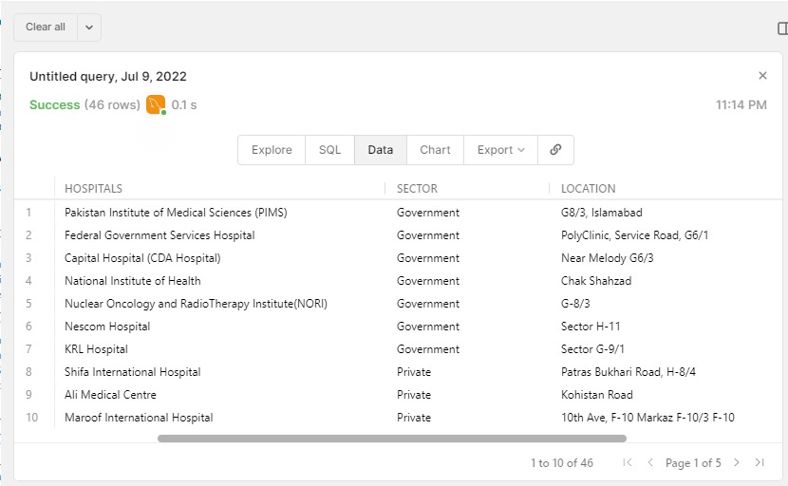

Figure . hospitals

This table contains 45 rows like this in the database.

### Shopping Malls:

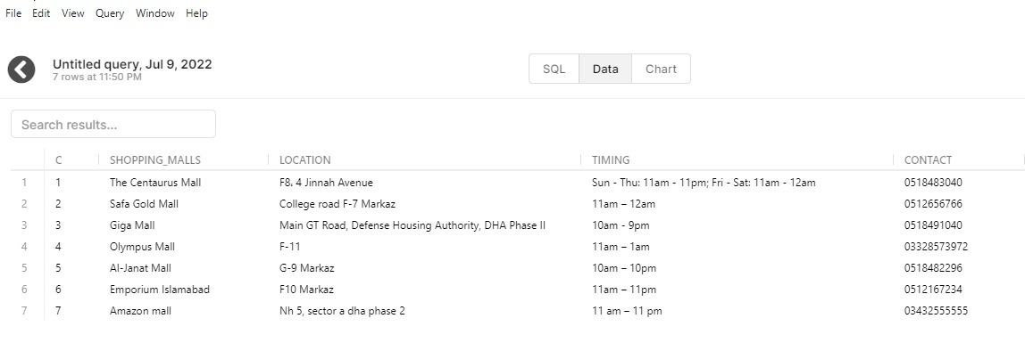

Figure . Shopping Malls

### Public Transport:

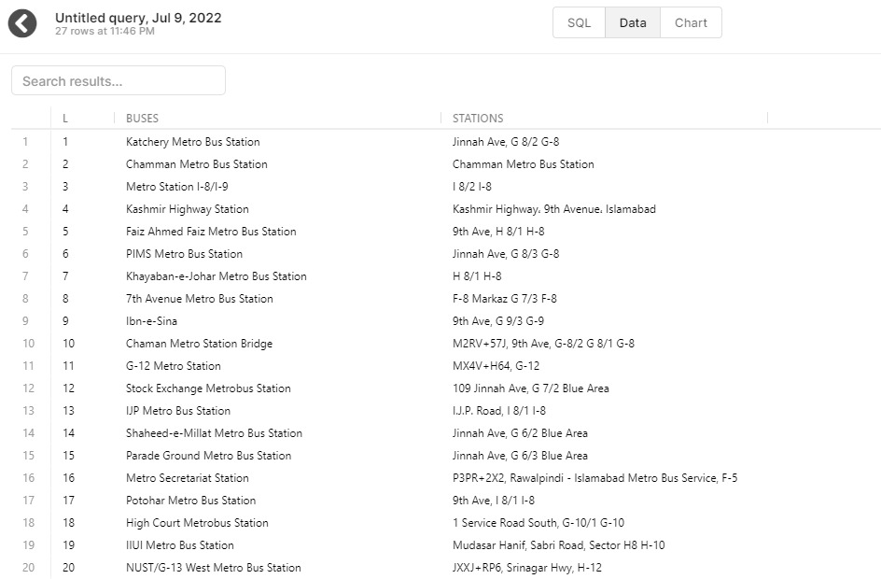

Figure . Public Transport

### Police Stations:

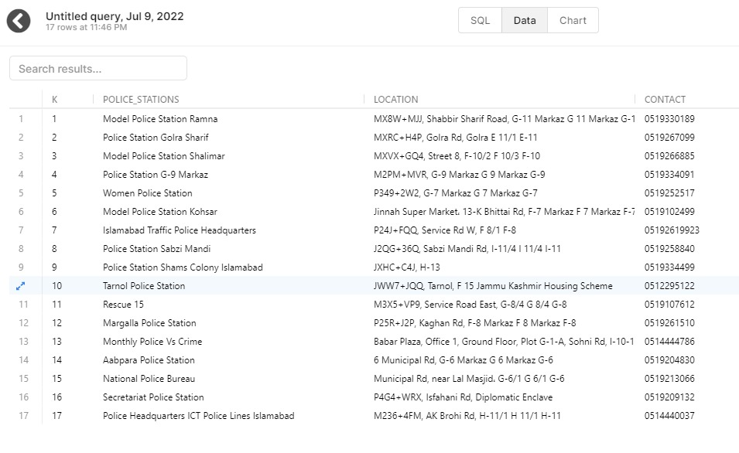

Figure . Police Stations

### Schools:

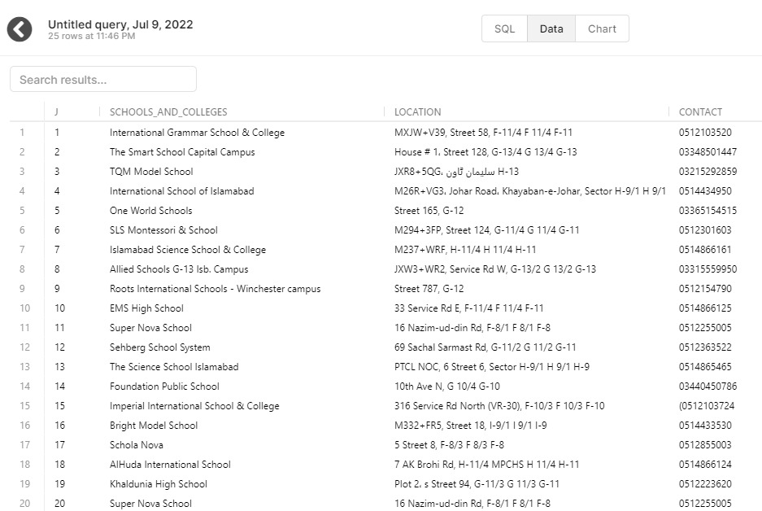

Figure . Schools

### Hotels:

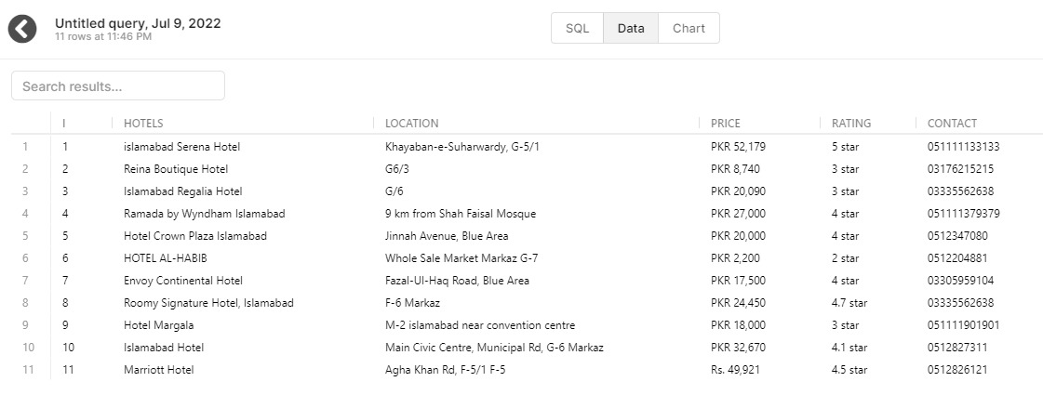

Figure . Hotels

### Libraries:

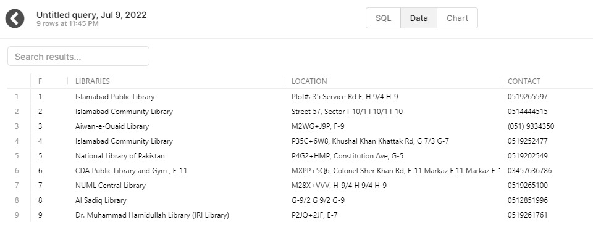

Figure . Libraries

### Universities:

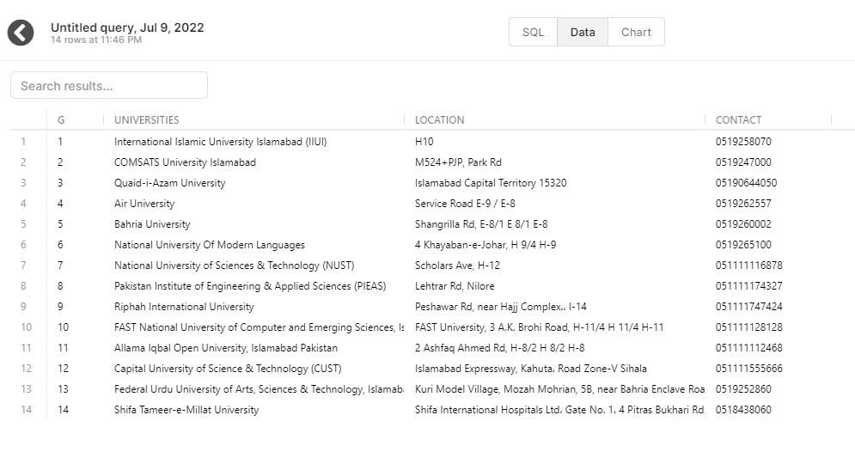

Figure . Universities

### ATMS:

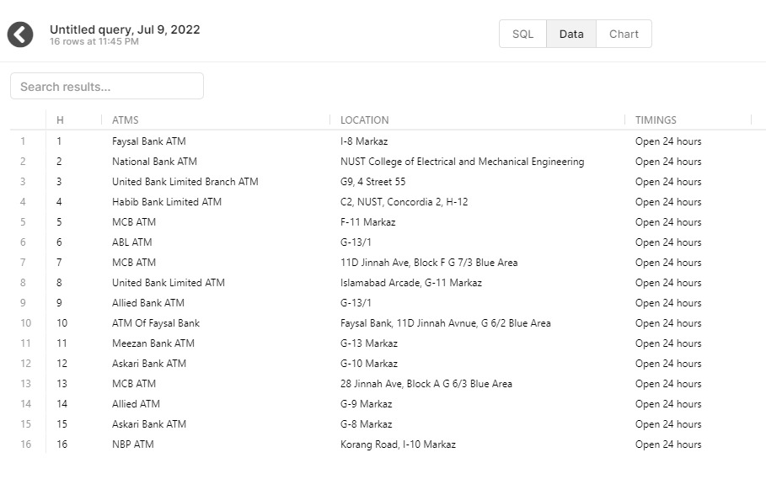

Figure . ATMS

### Cinemas:

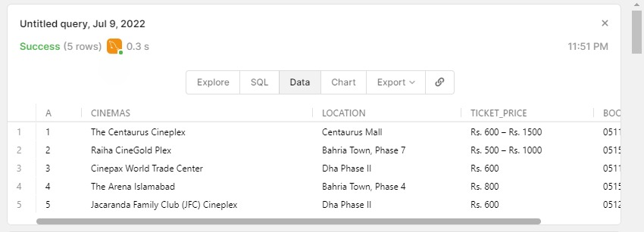

Figure .Cinemas

### Hostels:

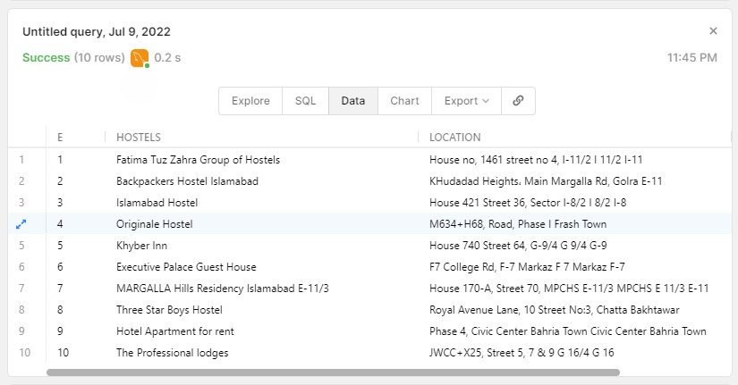

Figure . Hostels

### Restaurants:

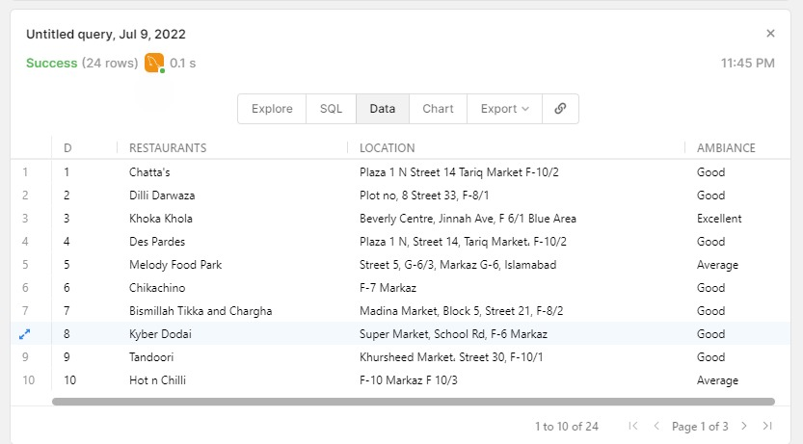

Figure . Restaurants

# Database Connectivity

## Connect Class:

A class Connect is made to connect the database and the java application as shown in the figure down below, the users respective Username and Password is used to access the database.

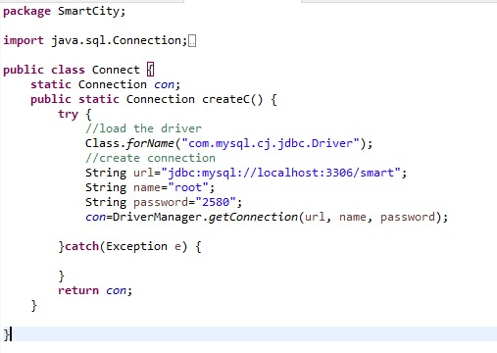

Figure . connect class

## Retrieve Data

Then another class is made to retrieve the values from the database after a successful connection is made. In the figure down below the function to retrieve data regarding the Airport is shown which gets the name, location and other relevant values to be used or displayed in the project and other classes

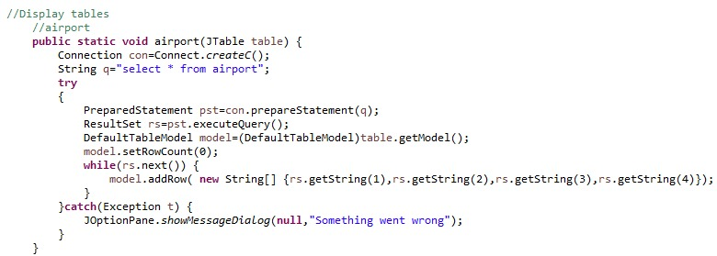

Figure . retrieve data

The same pattern is followed for the other tables.

## Login/Logout:

The classes such as Student, Tourist and Admin have similar functions, attached to the buttons which are common i.e. "Login", "Logout","Display Information". So by using the Polymorphism the same functions are used but in respective inherited class the working of the function is not same. For example the Login method for 3 different classes is shown:

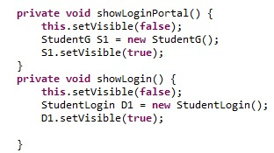 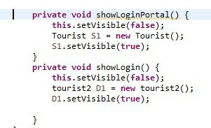

Figure . login/logout

# Java Concepts

## Setters And Getters:

We have declared setters and getters at various places to access the private variables anywhere. It maintains the privacy of the program and prevents the data from getting hacked. The values of the privated variables is accessed and modifies using the public getter ,setters.

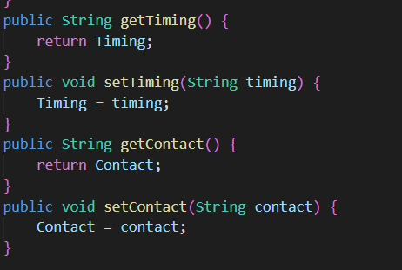

Figure . Setters and getters

## Constructor:

Wherever we have declared a class, we have also declared constructors for that class.

### Default Constructor:

While implementing the GUI, the whole work is done in the default constructor, for example, the screenshot provided below, shows how a Jframe is declared and designed in default constructor. This is a picture form one window only. All of the windows are declared on the same pattern

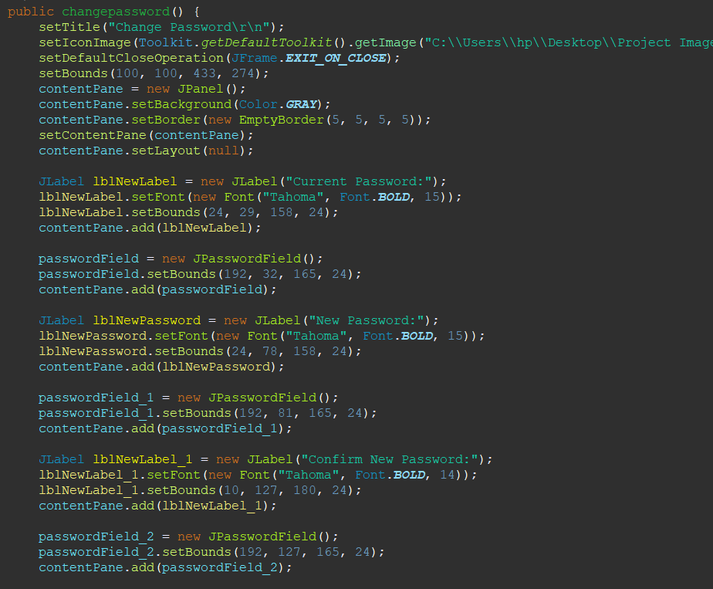

Figure . default Constructor

### Parameterized Constructor:

To connect the database to the GUI, we have declared several classes and methods. In these classes, we have used parameterized constructors. This is done to initialize the values of variables. For example, while logging in, we have take username and password input in gui. There is class in the database connection classes to comapare the login details with database to check if account exists or not. This class takes these 2 variables (username , password) as parameters and performs the actions on these two.

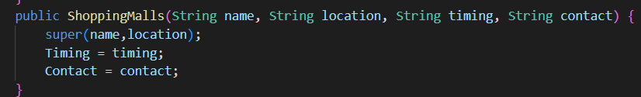

Figure . Parameterized Constructor

### Constructor Overloading:

We have used constructor overloading at several places to facilitate the program. For example, the constructor for login takes only username and password as parameters. While the constructor used for signup takes username, password, phonenumbber etc. This uses the concept of constructor overloading.

## Static Class Members, this Reference:

The keyword “this” is used a lot of times. Firstly it is used in GUI, when we have to close a particular Jframe and open a new Jframe, this reference is used to refer the JFrame to be closed. For example:

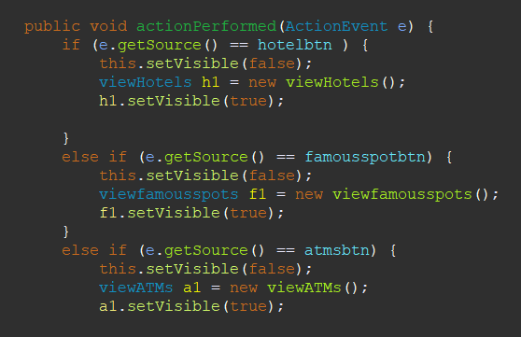

Figure . this reference

In some classes, there are made static functions to call them directly in other classes. This is used to facilitate the program. As to use these methods in other classes, we had to make an object of another class and then use that method. Here, static methods are declared to use these directly.

## Inheritance and Abstraction:

* There is an abstract superclass named “SmartCity”. This class is inherited by several classes. These include airport class, atm class, cinema class, police class, restaurant class, shopping malls class, schools class, university class, hospitals class, hostels class, libraries class, transport class, etc. This uses the concept of inheritance and abstraction. The abstract class mainly consists of variables and getters and setters which are then inherited by other classes.



Figure . inheritance

* There is an interface declared with the name ID that contains abstract methods. A class Administrator implements this ID interface. In this class, the body of these abstract methods is declared. This class is then inherited by the Student class and tourist class to access its methods in that class.
* While declaring the JFrame, all of the class, in which it was to be declared, inherit the class JFrame. In this way, we can access the non-private methods of the superclass in these subclasses and easily make the JFrame.
* While declaring Jbutton, the actionListener is made by implementing an interface named ActionListener. This interface has an abstract method called actionPerformed. In that method, all the commands for different buttons are coded.

## Superlass and Subclass:

### Super Class:

The abstact “Smart City” class here becomes the abstract superclass.

### Sub Class:

The classes that inherit this super class will be its subclasses. These are:

* Atm class
* Airport class
* Cinema class
* Restaurant class
* Shopping malls class
* Schools class
* University class
* Hospitals class
* Library class
* Hostels class
* Transport class
* Airport class

## UML Diagram:

The uml diagram of the super class smartCity and its subclasses is given below:

|  |
| --- |
| Cinemas |
| -ticketPrice: String  -bookingInfo: String |
| + Cinemas()  + Cinemas(String name, String location, String ticketPrice, String bookingInfo)  + getTicketPrice()  + setTicketPrice(String ticketPrice)  + getBookingInfo()  + setBookingInfo(String bookingInfo) |

|  |
| --- |
| Airport |
| -Contact: Private |
| + Airport()  + Airport(String name, String location, String contact)  + getContact()  + setContact(String contact) |

|  |
| --- |
| ATM |
| -Timing : String |
| + ATM()  + Atm(String name, String location, String timing)  + getTiming()  + setTiming(String timing) |

|  |
| --- |
| Schools |
| -contact: String |
| +Schools()  +Schools(String name, String location, String contact)  + getContact()  + setContact(String contact) |

|  |
| --- |
| Smart City (Abstract) |
| - Name : String  -Location: String |
| + SmartCity()  + SmartCity (String name, String location)  + getName(): String  + setName(String name)  + setLocation() : String  + setLocation(String location) |

|  |
| --- |
| Restaurant |
| -ambiance: String |
| + Restaurants()  + Restaurants(String name, String location, String ambiance)  + getAmbiance()  + setAmbiance(String ambiance) |

|  |
| --- |
| Police |
| -contact: String |
| + getContact()  + setContact(String contact) |

## Exception Handeling:

Wherever we have taken input from the user, we have done exception handeling. For example, when the user inputs any name, it is a common practice that the name would not contain any symbols or letters, that error is handeled here using try catch.



Figure . exception handeling 1

Now at places,if admin is adding a new organization to the database table, and he leaves some textfield empty by mistake , then that space in the database will be empty. This can dealt by adding following block of code.

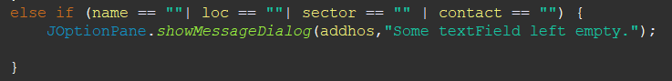

Figure . exception handeling 2

In the same manner, exception handling is done in the whole program.

## Graphical User Interface:

The whole UI of the program is designed using the java swing GUI. **Java Swing** is a part of Java Foundation Classes (JFC) that is *used to create window-based applications*. It is built on top of AWT (Abstract Windowing Toolkit) API and entirely written in java. Unlike AWT, Java Swing provides platform-independent and lightweight components. The javax.swing package provides classes for java swing API such as JButton, JTextField, JTextArea, JRadioButton, JCheckbox, JMenu, JColorChooser etc.

### JFrame:

We have declared several JFrames. Each JFrame conatins different labels, buttons etc. to make the program user interactive and user friendly.

#### Code:

To declare a JFrame, we have written the following block of code.



Figure . JFrame code 1

First we inherit the JFrame. Then using its non-private methods, we design the window like:



Figure . Jframe code 2

This explains the process of one window. All the other windows are also made following the same pattern.

### ContentPane:

In Java Swing, **the layer that is used to hold objects** is called the content pane. Objects are added to the content pane layer of the container. The getContentPane() method retrieves the content pane layer so that you can add an object to it. A content pane is an object created by the Java run time environment. So in each window , we have declared contentPane , where we have added all the objects. This code is same in all the other windows.

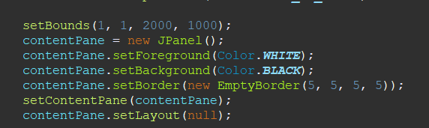

Figure . contentPane code

### JLabel:

To display the titles on the windows, we have used Jlabels. Several JaLabels aare declared to show each information.

#### Code:

The code of each JLabel is:

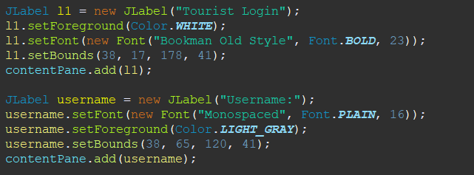

Figure . Jlabel code

For each Label, the code is same as shown above, just the text and position is changed.

### JtextArea:

To a display a text that that more than one line, we have used a JtextArea. The code for this is:

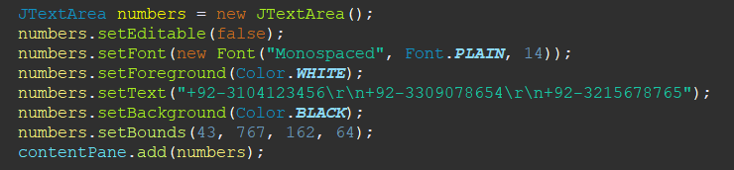

Figure . JTextArea code

The output of this will be as:

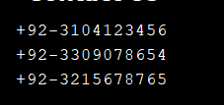

Figure . JTextArea Output

### JtextField:

To take input from the user, we have used JtextFields. The code for this is:

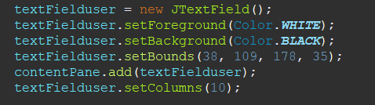

Figure . JTextField code

To store the value of this textField, we declare a string and write following block of code to store the value of it in a string.



Figure . JTextField value

This is done in the actionListener of button.

### JpasswordField:

To take password input form the user, we have used JpasswordField. The advantage of this is that in JpasswordField, the value written is not visible, rather dots apper.

The code for this is:

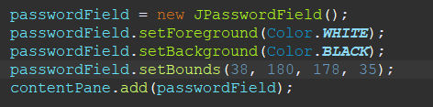

Figure . JPasswordField code

The output will be as:

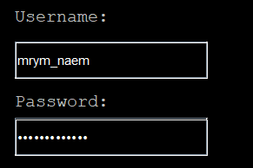

Figure JPasswordField output

The above one is a JtextField. And below one is JpasswordField.

To store the the value of this in a string, we first declare a char[] array. The following block of code is written:

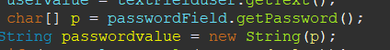

Figure . JPasswordField value

### JButton:

To execute specific commands, many Jbuttons are declared and each button has different commands and action Listeners. For example. In a window where there is diplay for tourist after login, we have declared several buttons, each button has different action listener as shown:

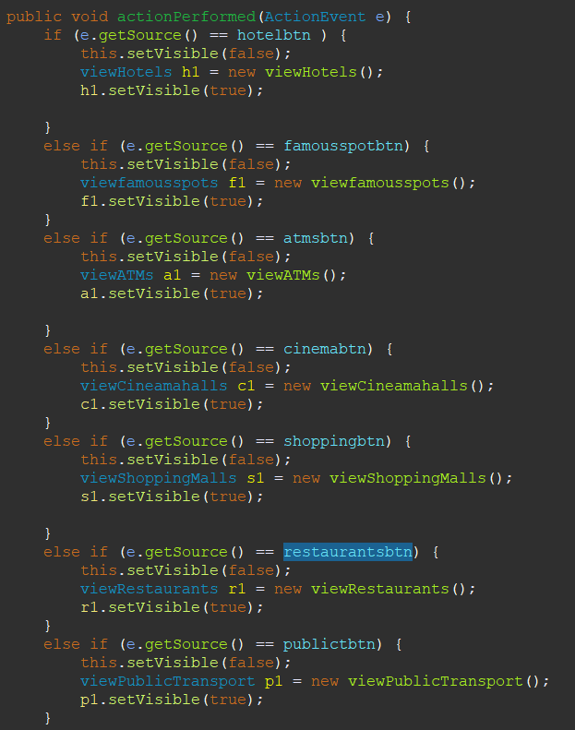

Figure . Action evevt

Here, we have first implemented the interface “action Listener”, that has an abstarct method called actionPerformed. e.getSource() expains that if that specific button is clicked.



Figure . actionlistener interface

Another method to add action Listener for a button without implentinng the interface :

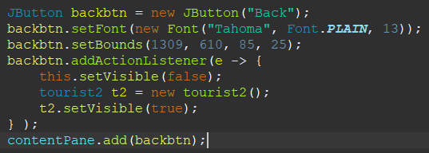

Figure . action event 2

In the program, there are several Jbuttons and in each Jbutton , there is an actionListener added by using either of these two methods.

# Conclusion:

In short, “The Smart City” Project provides information regarding the various aspects of the city such as tourism, institutes, industry, hospitals, geographical maps, ATM locations, etc. The implementation of this project solves most of the problems a new visitor faces while coming to a new city such as: path finding, hotel searching, transport searching and more. But, now this havoc has become easier with “Smart City Project” . Everything is provided under a single platform with only the click of a button. The project can be used by any person whether he is a tourist or a student, new in **Islamabad.** The project demonstrates the implementation of the Object Oriented Programming Principles such as Abstraction, Inheritance, Encapsulation and Polymorphism.